DIET Infrastructure
Our institution was first established in the year 1983, in kalayarkoil, sivagangai District. The institute is situated on the Kalayarkovil - Paramakudi in a campus with a beautiful tree trees, with modern facilities and sophisticated equipments. We are Proud that we have created good number of teachers to the society. Our teaching faculties has an excellent blend of academic background, experience and professional ability. This expert faculty ensures multi dimensional development of student with a balanced combination of theoretical as well as practical exposure. Our institute gave Innovative and gathering synergies for sourcing futuristic education to the student community for building a society of enlightened individuals with respect for life and ethics always promoting a novel culture of ‘Sharing your learning’ for a better tomorrow.

DIET MAP
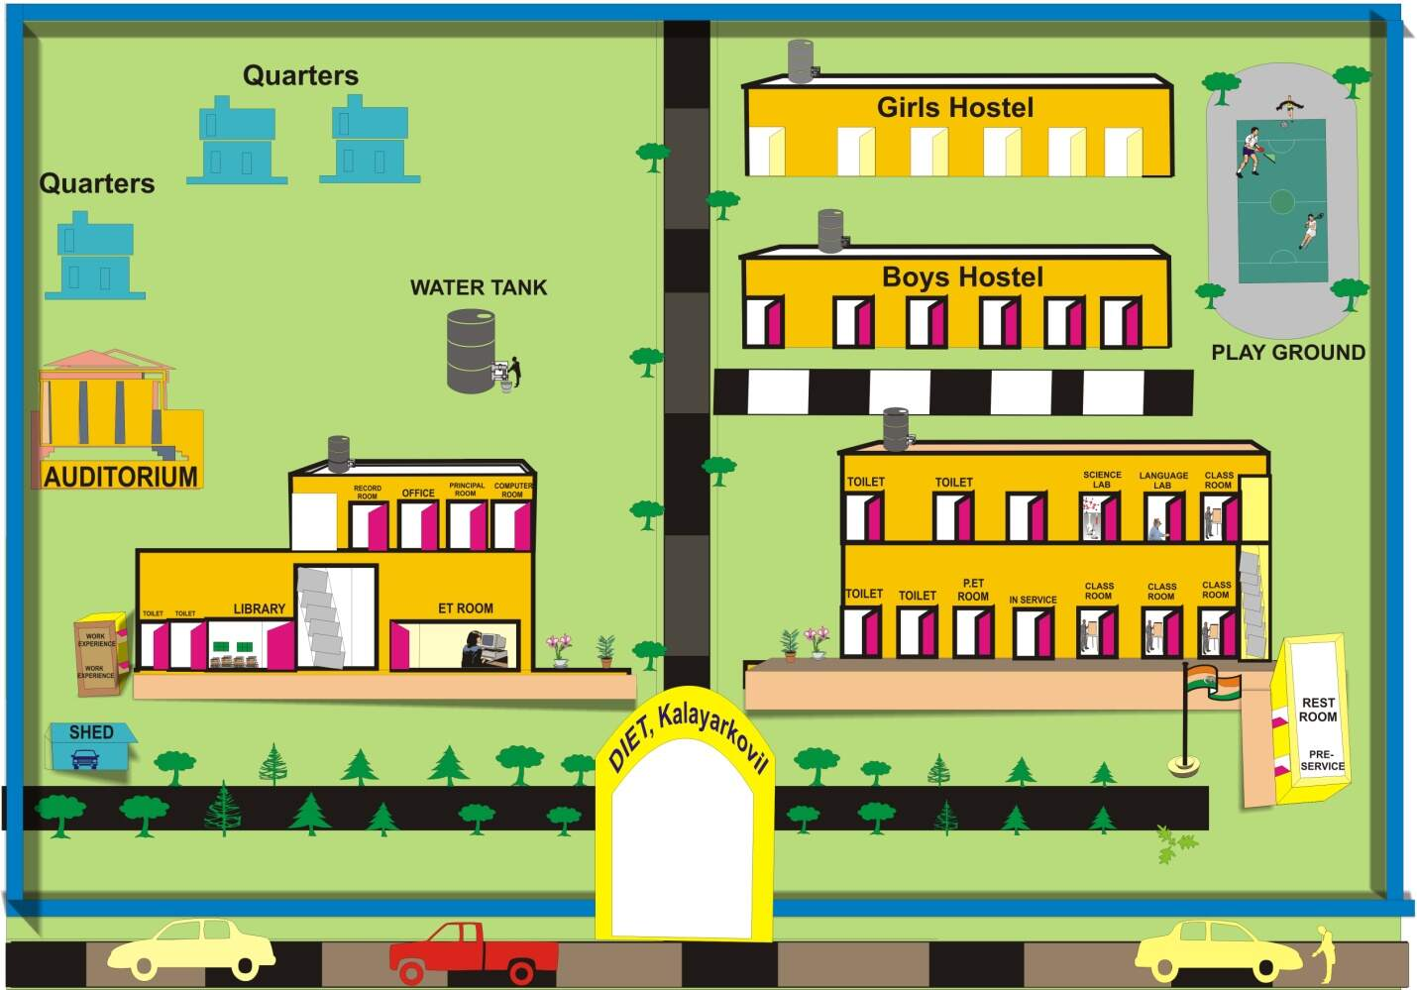
Land Area in Square meters – 45000
Built up area in Square meters - 7500

S.No | Infrastructure | Size in Sq. ft
a. | Classroom  - Classroom 1  - Class room2 | 746  746
b | Multipurpose Hall – 1 | 1376
c. | Auditorium | 1500
d. | Library – cum – Reading room | 1363
e. | ICT Resource Centre | 1495
f | Art& Resource Centre | 450
g | Health & Physical Education Resource Centre | 450
h. | Science Lab | 800
i. | Virtual Classroom | 746
j. | English language Lab | 746
k. | Smart Classroom | 1250
l. | Multipurpose Playfield | 10000
(ii) Facilities are available in the Institution
a. | Principal’s Office | Yes
b. | Staff Room | Yes
c. | Administrative Office | Yes
d. | Separate Common Room for male & female students | Yes
e. | Seminar Room | Yes
f | Separate Toilet facility for male & female students | Yes
g | Separate Toilet facility for Staff | Yes
i. | Parking Space | Yes
j. | Open space for Additional accommodation | Yes
k. | Store Room | Yes
l. | Medical facility | Yes
Facilities Available in the Institute

